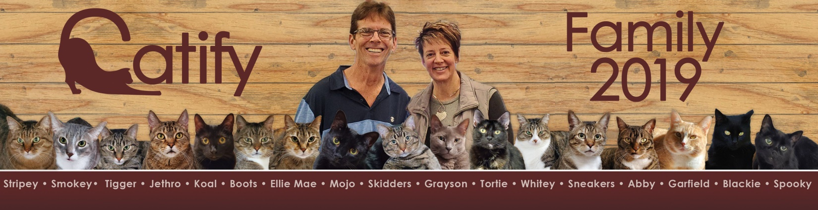
Saturday, December 19, 2020
To all our Family, Friends and Supporters;
What a Year for 2020 !! Amazing how an upper respiratory influenza flu bug has caused so much collateral damage, both personally and financially. Our hearts go out to those who have lost lives as well as those who have been affected by loss of businesses, income, depression and more. This has been a situation where ALL People have been affected by this virus one way or another.
For us, our dream was placed on hold as it broke out in January when we were about to secure a SBA loan for a substantial amount to open what started out to be a 3500 sq. ft. facility and grew over four changes to a 10,000 sq. ft. facility with four separate businesses in one complex under the same roof.
Business #1: Cat Adoption Center with four, 20’ X 24’ home style rooms with 12-18 cats in each room (no cage facility) where you can go in and play with and get to know the cats to find the one(s) that would be the best fit for the adopters. The four rooms would house Kittens to 1 year olds, then 1 to 9 years old, then 9+ years (seniors) and finally, special needs cats. Cats in our trusted care would all have a chance to find their forever homes without having to worry about any of them being put down due to over population !! We would be a “No Kill” facility, unless the cat was suffering and beyond medical care of being able to healed from their issues.
Business #2: Large Coffee & Special Pastry House with a dining section for “Dining with the Cats”. Great for college students to come in and do their homework, work force for lunches or snack, people in general who want to just get away and have some down time with the cats. A drive thru would be there for folks to come and take the drinks/coffee/pastries to go.
Business #3: Full Care Facility for cats with TWO onboard Veterinarians. We would be providing Low Cost Services for Sickness Care, Wellness Care, Spay/Neuter Services. We would be a “State of the Art” Facility with in house blood labs for immediate results, x-rays, dental x-rays, cold laser treatments & more. Kris, (my wife) is now looking into becoming certified & licensed to do Chiropractic Adjusting on animals as well as her current practice we have. We, based on experience, want to be able to provide your feline with the best of care, immediately, without having to wait 1-3 days for results from external labs. Therefore, all care & surgeries would be done In-House !!
Business #4: Cat Resort Boarding: We would have 5-6 Low Cost rooms of 10’ X 12’ & 11’ X 14’ where we could house your 1, 2, 3 or more cats all together, NON-CAGED, in a home style environment that either we provide or partially provide and you add your own personal items your furry ones are accustom to (like, cat beds, cat trees, toys, etc). Each room will also have their own, wall mounted, flat screen TV with Hallmark movies on from 7am until 11pm and a “Live Kitty Cam” that you can zoom in on and keep tabs on your “kids” while you are on vacation, working trip, etc. Your family members would be treated well every day, fed, treats and lots of love.
So, where do we go from here?? Being a 501C3 Non-Profit Organization, we have to always leave our political and governmental views at home. However, this is posted strictly to explain why we made the decisions we have up to this point. It is not being stated because of what our personal beliefs are !!
Back in January 2020, we were talking with both Huntington Bank and US Bank SBA loan officers, that both banks loved our business plan and projections. All we had to do was to move forward and we would have been open in all honesty probably by the 1st of May. Covid came at the end of January and by Mid-February we were skittish on signing for such a large loan since I would be responsible for payback. Our business would have been considered NON-ESSENTIAL and we would have been affected financially right out of the gate!! So we took a “Wait and See” approach and thought we would revisit it by late Summer. Well, here we are….. the daily new NUMBER of cases of Covid-19 (which Daily Numbers includes PAST cases and PROBABLE cases (untested)) the government officials at the helm are painting a grim picture. This makes it hard for us to raise funds with the generosity of donors currently due to the uncertainty of this pandemic.
Our main concern for starting and operating is for the felines that would be entrusted to us for care and finding forever homes. We DO NOT want to get all open only to just return the cats back to the rescue facilities due to lack of income from being able to operate NORMALLY. This would be too stressful on the felines bouncing them from one place to another. It’s sad that actual children experience this in real life. I would not want to be the cause of that to the kittens and cats that we would be in charge of. Our cats we would get to adopt out, would come from rescue facilities, but unlike other facilities that would return them if not adopted out….. ours would STAY with us until adopted out or be loved at our facility daily until their natural life ends. So bottom line, we are in the process of seeing HOW we can navigate from this point forward to OPEN, Stay Open and achieve “our goals, set forth from our board” without interference of this pandemic. Under normal conditions, we would be financially viable within the first year of operation, and that is what we are now going to try to navigate through in the next upcoming months.
In the meantime, we are still raising funds from donations, items donated that we are selling on eBay that 100% of the proceeds are going to our cause. If you would like to help or see what we are selling from time to time you can email us at office@catifycafe.org and we will email you a direct link to eBay. If you would like to make a donation by cash or check, send to:
Catify Café & Adoptions, Inc.
P. O. Box 21
Orrville, OH 44667-0021

Our Phone to leave a Message & Best Time(s) to call back: 330-465-2568

If you wish to make a Credit Card Donation, please email us for a direct link for our Paypal Non-Profit Account.

If you have Items of Value you no longer need or want or even want a 501C3 Tax Receipt for your donation, email us and we will call you to set up a time. Those items would then be listed on eBay and you can even follow the progress to see what they would bring us financially.

In the meantime, we will update you again towards the end of January 2021 with our progress and decisions made. A BIG THANK YOU for our supporters thus far !! We wish you all a Very Merry Christmas and Happy New Year !!

